**FHARefi_ENC_10540_26509_MaxMtgCalculation**

**Automated Test Script Design**

|  |  |  |  |  |
| --- | --- | --- | --- | --- |
| **Step#** | **Step Description** | **Expected Result** | **Action Name** | **Case Name** |
| **1** | Click on Pipeline tab and create a new loan according to data points in 'Test Data' section | Loan Created | TC1-Checkbox Simple Refinance FHA to FHA | TC #1 ENC-10540 - FHA Maximum Mortgage Calculation Updates: New Checkbox 'Simple Refinance (FHA to FHA)' |
| **2** | Click on 'FHA Management' > 'Basic Info' form | In the 'Purpose of Loan' section, validate the check box 'Simple Refinance (FHA to FHA)' is displayed above 'Streamline (w/appraisal)' and check box can be selected & saved. |  |  |
| **3** | Click on 'FHA Management' > 'Prequalification' form | In the 'Purpose of Loan' section, validate the check box 'Simple Refinance (FHA to FHA)' is displayed above 'Streamline (w/appraisal)' and check box can be selected & saved. |  |  |
| **4** | Click on 'HUD-92900LT FHA Loan Transmittal' form | In the 'Purpose of Loan' section, validate the check box 'Simple Refinance (FHA to FHA)' is displayed above 'Streamline (w/appraisal)' and check box can be selected & saved. |  |  |
| **5** | Update needed Loan Data for TC 2 according to the document | Loan modified | TC2-TC3-FHA Management Prequalification Updates | TC #2 ENC-10540 - FHA Maximum Mortgage Calculation Updates: FHA Management Prequalification Updates (No Cash-Out Refi) |
| **6** | Click on '2015 Itemization' form and add fees.  (Go to 2015 Itemization, enter 801a-Loan Origination Fee=1.0%  Go to RegZ-LE, enter 1st Payment Date.  Go to 2015 Itemization, enter 901 Interest from) | F137 value is populated  F138 value is populated |  |  |
| **7** | Click on 'FHA Management' > 'Prequalification' form | Validate the following sections are displayed in lieu of the old 'Mortgage Calculation' section (see attached screen shot):  * 'LTV Factor Calculation-Basic'  * 'Exiting Debt Calculation'  * Maximum Mortgage Amount'  Validate the existing 'Ratio' and 'EEM' sections are displayed below the new 'Mortgage Calculation' section.  Validate the "Basic LTV Factor Calculation":  * 'Appraised Value' (F356) = $250,000  * LTV Factor = 97.75% (should be displayed)  * Calculation = $244,375 (Appraised Value * LTV Factor)  Validate the "Existing Debt Calculation":  * 'Unpaid Principal Balance' (F26) = $205,000  * 'Borrower Paid Closing Costs' (F137) = Value determined from Itemization Form data  * 'Prepaid Expenses' (F138) = Value determined from Itemization Form data  * 'Discount Points' (F1093) = $1000  * 'Repairs & Improvements' (F29) = $25,000  * 'MIP Refund' (F1134) = $500  * Calculation: 'Existing Debt' = 'Unpaid Principal Balance' (F26) + 'Total Closing Costs' (F1132) ['Estimated Closing Costs' (F137) + 'Estimated Prepaid Items' (F138)] + 'Discount Points' (F1093) +'Repairs & Improvements' (F29) - 'MIP Refund'  Validate the 'Mortgage Basis'(GMCAW.X1)is lesser of the following:  * 'LTV Factor Calculation'  or  * 'Existing Debt Calculation' |  |  |
| **8** | Change the data point values for either the 'LTV Factor Calculation' or 'Existing Debt Calculation' such that the 'Existing Debt' (F3052) or 'Multiplied by LTV Factor' (F1154) is less than the other (opposite of step 3).  Ex. if in step 3, 'LTV Factor Calculation' was the lesser, then revise the data point values that would result in the 'Existing Debt Calculation to now be the lesser. | Validate the 'Mortgage Basis'(GMCAW.X1) is lesser of the following:  * 'LTV Factor Calculation'  or  * 'Existing Debt Calculation' |  |  |
| **9** | Update needed Loan Data for TC 3 according to the document | Loan Modified |  | TC #3 ENC-10540 - FHA Maximum Mortgage Calculation Updates: FHA Management Prequalification Updates (Cash-Out Refi) |
|  |  |  |  |  |
| **10** | Click on 'FHA Management' > 'Prequalification' form | Validate the following sections are displayed (see attached screenshot #1):  * 'LTV Factor Calculation-Basic'  * Maximum Mortgage Amount'  Validate the "LTV Factor Calculation":  * Purchase Date (F1518) = Date entered from setup of new loan (Step 1)  * Application Date (F745) = System default date  * 'Appraised Value' (F356) = $250,000  * LTV Factor = 85.00% (Should be displayed)  * Calculation: 'Multiplied by LTV Factor' (F1154) = $212,500 (Appraised Value * LTV Factor)  Validate the 'Mortgage Basis'(GMCAW.X1) = 'Multiplied by LTV Factor' (F1154) ($212,500) |  |  |
| **11** | Change F1518 (Purchase Date) to be less than 12 months before Application Date (F745) | F1518 (Purchase Date) = Less than 12 months before Application Date (F745)  F1518 (Purchase Date) is updated |  |  |
| **12** | Click on 'FHA Management' > 'Prequalification' form | Validate the following sections are displayed (see attached screenshot #2):  * 'LTV Factor Calculation-Basic'  * Maximum Mortgage Amount'  Validate the "LTV Factor Calculation":  * Purchase Date (F1518) = Date changed from step 3  * Application Date (F745) = System default date  * 'Appraised Value' (F356) = $250,000  * 'Original Sales Price' (F356) = $225,000  * 'Lesser of 1 or 2' (Field # is TBD) = $225,000  * LTV Factor = 85.00% (Should be displayed)  * Calculation: 'Multiplied by LTV Factor' (F1154) = $191,250 (Original Sales Price * LTV Factor)  Validate the 'Mortgage Basis'(GMCAW.X1) = 'Multiplied by LTV Factor' (F1154) ($191,250) |  |  |
| **13** | Changed EEM.X63 (Original Sales Price) to $250,001 | **Validate** Appraised Value  EEM.X63 (Original Sales Price) = $250,001  EEM.X63 (Original Sales Price) is updated |  |  |
| **14** | Click on 'FHA Management' > 'Prequalification' form | Validate the "LTV Factor Calculation":  * Purchase Date (F1518) = Date changed from step 3  * Application Date (F745) = System default date  * 'Appraised Value' (F356) = $250,000  * 'Original Sales Price' (F356) = $250,001  * 'Lesser of 1 or 2' (Field # is TBD) = $250,000  * LTV Factor = 85.00% (Should be displayed)  * Calculation: 'Multiplied by LTV Factor' (F1154) = $212,500 (Appraised Value * LTV Factor)  Validate the 'Mortgage Basis'(GMCAW.X1) = 'Multiplied by LTV Factor' (F1154) ($212,500) |  |  |
| **15** | Update needed Loan Data for TC 4 according to the document | Loan Modified | TC4-TC5-FHA Management Prequalification Updates-Streamline | TC #4 ENC-10540 - FHA Maximum Mortgage Calculation Updates: FHA Management Prequalification Updates (Streamline No Appraisal) |
| **16** | Click on 'FHA Management' > 'Prequalification' form | User is navigated to the 'FHA Management' > 'Prequalification' form  Validate the following sections are displayed (see attached screenshot):  * 'Existing Debt Calculation'  * Maximum Mortgage Amount'  Validate the "Existing Debt Calculation":  * 'Unpaid Principal Balance' (F26) = $205,000  *'MIP Refund' (F1134) = $500  * Calculation: 'Existing Debt' = 'UnpaidPrincipal Balance' (F26) - 'MIP Refund'  Validate the "Maximum Mortgage Calculation":  Existing Debt' (F3052) + 'UFMIP' (F1045) = 'Mortgage Basis'(GMCAW.X1) |  |  |
| **17** | Update needed Loan Data for TC 5 according to the document | Loan Modified |  | TC #5 ENC-10540 - FHA Maximum Mortgage Calculation Updates: FHA Management Prequalification Updates (Streamline with Appraisal) |
| **18** | Click on 'FHA Management' > 'Prequalification' form | User is navigated to the 'FHA Management' > 'Prequalification' form  Validate the following sections are displayed (see attached screenshot):  * Maximum Mortgage Amount'  Validate the "Maximum Mortgage Calculation":  'Unpaid Principal Balance (F26) + 'UFMIP' (F1045) = 'Mortgage Basis'(GMCAW.X1**)** |  |  |
|  |  |  |  |  |
|  |  |  |  |  |
|  |  |  |  |  |
|  |  |  |  |  |

**CASE#1**

1. ADD: to the following screens:

FHA Management Basic Information and FHA Management Pre-qual and HUD 92900 LT above the checkbox Streamline (w/appraisal) a new checkbox selection of

a. Simple Refinance (FHA to FHA) [This field needs to be selectable in addition to a selection from field 19]

|  |  |  |  |
| --- | --- | --- | --- |
| 1 | Log into Encompass as Admin User |  |  |
|  | Click on Pipeline tab and create a new loan according to data points in 'Test Data' section | * F4000 (First name) = Richard  * F4002 (Last Name) = Borrower  * F52 (Marital Status) = Married  * F65 (SSN) = 991919991  * F1401 (Date of Birth) = 10/30/1980  * F4008 (Type) = Individual  * F1240 (Home Email) = email@email.com  * F1172 (Loan Type) = FHA  * F420 (Lien Position) = First  * F763 (Est Closing Date) = Date After Application  * F608 (Amortization Type) = Fixed  * F1811 (Property Will Be) = Primary  * F1109 (Loan Amount) = $200,000  * F3 (Note Rate) = 4%  * F1014 (Qual Rate) = 4%  * F4 (Term) = 360  * F325 (Due In) = 360  * F1821 (Estimated Value) = $250,000  * F356 (Appraised Value) = $250,000  * F11 (Address) = 123 Subject Property  * F12 (City) = Anaheim  * F13 (County) = Orange  * F14 (State) = CA  * F15 (Zip) = 92802  * F1041 (Property Type) = Detached  * F682 (First Payment Date) = First of month just after F763 (Est Closing Date)  * F2553 (Disbursement Date) = 3 business days after  * L244 (Interest From) = Same as F2553 (Disbursement Date)  * F748 (Closing Date) = Same as * F763 (Est Closing Date)  * SYS.X2 (Days Per Year) = 365  * F672 (Late Payment > 'If a payment is more than) = Any value  * F674 (Late Payment > 'you will be charged) = Any value  * F1719 (Late Payment "Drop Down") = Any value  * FL0102 (Liabilities > Company name) = Subject Property Mortgage  * FL0108 (Liabilities > Type) = Mortgage  * FL0113 (Liabilities > Balance) = $190,000  * FL0111 (Liabilities > Payment) = $1300  * FL0112 (Liabilities > Mos Left) = 300  * FL0118 (Liabilities > Paid Off) = "checked"  FHA Loan is created. |  |
| 2 | Click on 'FHA Management' > 'Basic Info' form | User is navigated to the 'FHA Management' > 'Basic Info' form | In the 'Purpose of Loan' section, validate the check box 'Simple Refinance (FHA to FHA)' is displayed above 'Streamline (w/appraisal)' and check box can be selected & saved. |
| 3 | Click on 'FHA Management' > 'Prequalification' form | User is navigated to the 'FHA Management' > 'Prequalification' form | In the 'Purpose of Loan' section, validate the check box 'Simple Refinance (FHA to FHA)' is displayed above 'Streamline (w/appraisal)' and check box can be selected & saved. |
| 4 | Click on 'HUD-92900LT FHA Loan Transmittal' form | User is navigated to the 'HUD-92900LT FHA Loan Transmittal' form | In the 'Purpose of Loan' section, validate the check box 'Simple Refinance (FHA to FHA)' is displayed above 'Streamline (w/appraisal)' and check box can be selected & saved. |

**CASE#2**

2. Rate and Term Refinance: When field 19 = No Cash-Out Refinance, modify the UI on the FHA Management Prequalification screen so that the mortgage calculation represents the 3 sections laid out below:

a. LTV Factor Calculation - Basic

i. Appraised Value [FIELD 356] * 97.75 % LTV Factor (show LTV Factor on screen) = [Field 1154] – change HH for field 1154

b. Existing Debt Calculation

i. Unpaid Principal Balance [ field 26] + borrower paid closing costs [field 137] + Discount Points [field 1093] + Prepaid Expenses [field 138] + Borrower paid repairs [field 29] – MIP Refund [field 1134] = Existing Debt [field 3052 - calculation] Modify HH for field 3052 on FHA 203B refinance loans

c. Maximum Mortgage Amount

i. Mortgage Basis [Re-use field GMCAW.X1] to equal the lesser of the LTV Factor calculation or the Existing Debt Calculation

|  |  |  |  |
| --- | --- | --- | --- |
| 1 | Log into Encompass as Admin User |  |  |
|  | Click on Pipeline tab and create a new loan according to data points in 'Test Data' section | * F4000 (First name) = Richard  * F4002 (Last Name) = Borrower  * F52 (Marital Status) = Married  * F65 (SSN) = 991919991  * F1401 (Date of Birth) = 10/30/1980  * F4008 (Type) = Individual  * F1240 (Home Email) = email@email.com  * F1172 (Loan Type) = FHA  * F19 (Purpose of Loan) = No Cash-Out Refi  * F420 (Lien Position) = First  * F763 (Est Closing Date) = Date After Application  * F608 (Amortization Type) = Fixed  * F1811 (Property Will Be) = Primary  * F1109 (Loan Amount) = $200,000  * F3 (Note Rate) = 4%  * F1014 (Qual Rate) = 4%  * F4 (Term) = 360  * F325 (Due In) = 360  * F1821 (Estimated Value) = $250,000  * F356 (Appraised Value) = $250,000  **\* F26 (Unpaid Principal Balance) = $205,000 – FNMA Streamlined, 1003p1**  **\* F1093 (Discount Points) = $1000 - FNMA Streamlined, 1003p3**  **\* F205 (Describe Improvements) = Any text - 1003p1**  **\* F30 (Made or To Be Made) = Checked - 1003p1**  **\* F29 (Cost) = $25,000 - 1003p1**  **\* F1134 (MIP Refund) = $500 - FNMA Streamlined**  * F11 (Address) = 123 Subject Property  * F12 (City) = Anaheim  * F13 (County) = Orange  * F14 (State) = CA  * F15 (Zip) = 92802  * F1041 (Property Type) = Detached  * F682 (First Payment Date) = First of month just after F763 (Est Closing Date)  * F2553 (Disbursement Date) = 3 business days after  * L244 (Interest From) = Same as F2553 (Disbursement Date)  * F748 (Closing Date) = Same as * F763 (Est Closing Date)  * SYS.X2 (Days Per Year) = 365  * F672 (Late Payment > 'If a payment is more than) = Any value  * F674 (Late Payment > 'you will be charged) = Any value  * F1719 (Late Payment "Drop Down") = Any value  * FL0102 (Liabilities > Company name) = Subject Property Mortgage  * FL0108 (Liabilities > Type) = Mortgage  **\* FL0113 (Liabilities > Balance) = $205,000**  * FL0111 (Liabilities > Payment) = $1300  * FL0112 (Liabilities > Mos Left) = 300  * FL0118 (Liabilities > Paid Off) = "checked" | Loan Created |
| 2 | Click on '2015 Itemization' form and add fees manually or select a Closing Costs template that would derive an 'Estimated Closing Costs' value (F137) and 'Estimated Prepaid Items' (F138) | Go to 2015 Itemization, enter 801a-Loan Origination Fee=1.0%  Go to RegZ-LE, enter 1st Payment Date 09/01/2015  Go to 2015 Itemization, enter 901 Interest from 07/22/2015 | F137 value is populated  F138 value is populated |
| 3 | Click on 'FHA Management' > 'Prequalification' form | User is navigated to the 'FHA Management' > 'Prequalification' form | Validate the following sections are displayed in lieu of the old 'Mortgage Calculation' section (see attached screen shot):  * 'LTV Factor Calculation-Basic'  * 'Exiting Debt Calculation'  * Maximum Mortgage Amount'  Validate the existing 'Ratio' and 'EEM' sections are displayed below the new 'Mortgage Calculation' section.  Validate the "Basic LTV Factor Calculation":  * 'Appraised Value' (F356) = $250,000  * LTV Factor = 97.75% (should be displayed)  * Calculation = $244,375 (Appraised Value * LTV Factor)  Validate the "Existing Debt Calculation":  * 'Unpaid Principal Balance' (F26) = $205,000  * 'Borrower Paid Closing Costs' (F137) = Value determined from Itemization Form data  * 'Prepaid Expenses' (F138) = Value determined from Itemization Form data  * 'Discount Points' (F1093) = $1000  * 'Repairs & Improvements' (F29) = $25,000  * 'MIP Refund' (F1134) = $500  * Calculation: 'Existing Debt' = 'Unpaid Principal Balance' (F26) + 'Total Closing Costs' (F1132) ['Estimated Closing Costs' (F137) + 'Estimated Prepaid Items' (F138)] + 'Discount Points' (F1093) +'Repairs & Improvements' (F29) - 'MIP Refund'  Validate the 'Mortgage Basis'(GMCAW.X1)is lesser of the following:  * 'LTV Factor Calculation'  or  * 'Existing Debt Calculation' |
| 4 | Change the data point values for either the 'LTV Factor Calculation' or 'Existing Debt Calculation' such that the 'Existing Debt' (F3052) or 'Multiplied by LTV Factor' (F1154) is less than the other (opposite of step 3).  Ex. if in step 3, 'LTV Factor Calculation' was the lesser, then revise the data point values that would result in the 'Existing Debt Calculation to now be the lesser. |  | Validate the 'Mortgage Basis'(GMCAW.X1) is lesser of the following:  * 'LTV Factor Calculation'  or  * 'Existing Debt Calculation' |

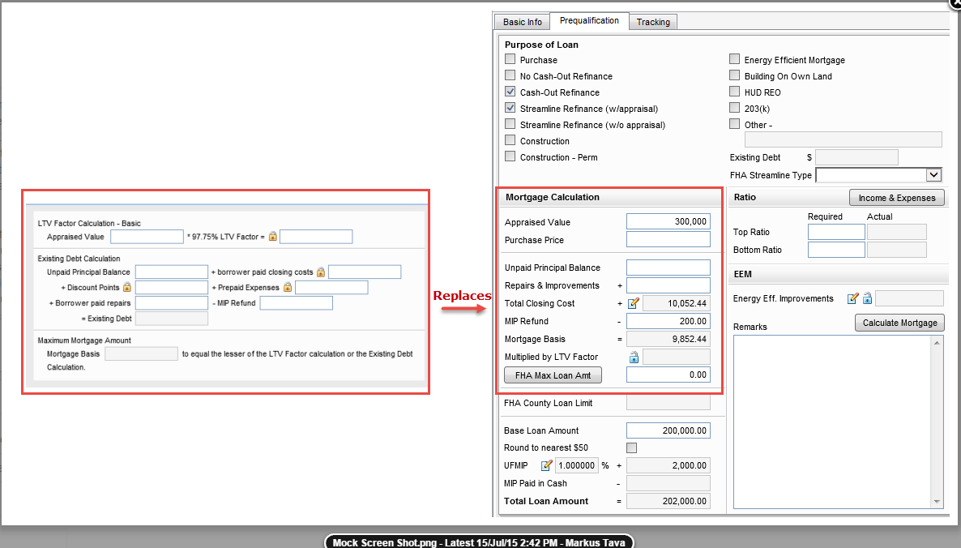

**CASE#3**

3. Cash-Out Refinance: When field 19 = Cash-Out Refinance, modify the UI on the FHA Management Prequalification screen so that the mortgage calculation represents the 2 sections laid out below:

a. LTV Factor Calculation

i. If Purchase date [field 1518] is greater than Application date [field 745] by 365 days then:

1. Appraised Value [FIELD 356] * 85.00 % LTV Factor (show LTV Factor on screen) = [1154] – change HH for field 1154

ii. If Purchase date [field 1518] is Less than 365 days from Application date [field 745] then:

1. Appraised Value [field 356]

2. Original Sales Price [EEM.X63]

3. Lesser of 1 or 2 [NF] * 85.00 % LTV Factor (show LTV Factor on screen) = 1154 – modify HH for field 1154

b. Maximum Mortgage Amount

i. Mortgage Basis [Re-use field GMCAW.X1] to equal the lesser of the above LTV Factor calculations

Test Details

Test Details

|  |  |  |  |
| --- | --- | --- | --- |
| **No** | **Test Step** | **Test Data** | **Expected Result** |
| 1 | Log into Encompass as Admin User  Click on Pipeline tab and create a new loan according to data points in 'Test Data' section | * F4000 (First name) = Richard  * F4002 (Last Name) = Borrower  * F52 (Marital Status) = Married  * F65 (SSN) = 991919991  * F1401 (Date of Birth) = 10/30/1980  * F4008 (Type) = Individual  * F1240 (Home Email) = email@email.com  * F1172 (Loan Type) = FHA  * **F19 (Purpose of Loan) = Cash-Out Refi**  **\* F1518 (Purchase Date) = GREATER than 12 months before Applicatio**n Date (F745)  * F420 (Lien Position) = First  * F763 (Est Closing Date) = Date After Application (F745)  * F608 (Amortization Type) = Fixed  * F1811 (Property Will Be) = Primary  * F1109 (Loan Amount) = $200,000  **\* EEM.X63 (Original Sales Price) = $225,000**  * F3 (Note Rate) = 4%  * F1014 (Qual Rate) = 4%  * F4 (Term) = 360  * F325 (Due In) = 360  * F1821 (Estimated Value) = $250,000  * F356 (Appraised Value) = $250,000  **\* F26 (Unpaid Principal Balance) = $180,000**  * F1093 (Discount Points) = $1000  * F205 (Describe Improvements) = Any text  * F30 (Made or To Be Made) = Checked  * F29 (Cost) = $25,000  * F1134 (MIP Refund) = $500  * F11 (Address) = 123 Subject Property  * F12 (City) = Anaheim  * F13 (County) = Orange  * F14 (State) = CA  * F15 (Zip) = 92802  * F1041 (Property Type) = Detached  * F682 (First Payment Date) = First of month just after F763 (Est Closing Date)  * F2553 (Disbursement Date) = 3 business days after  * L244 (Interest From) = Same as F2553 (Disbursement Date)  * F748 (Closing Date) = Same as * F763 (Est Closing Date)  * SYS.X2 (Days Per Year) = 365  * F672 (Late Payment > 'If a payment is more than) = Any value  * F674 (Late Payment > 'you will be charged) = Any value  * F1719 (Late Payment "Drop Down") = Any value  * FL0102 (Liabilities > Company name) = Subject Property Mortgage  * FL0108 (Liabilities > Type) = Mortgage  **\* FL0113 (Liabilities > Balance) = $180,000**  * FL0111 (Liabilities > Payment) = $1300  * FL0112 (Liabilities > Mos Left) = 300  * FL0118 (Liabilities > Paid Off) = "checked"  Loan is created |  |
| 2 | Click on 'FHA Management' > 'Prequalification' form |  | Validate the following sections are displayed (see attached screenshot #1):  * 'LTV Factor Calculation-Basic'  * Maximum Mortgage Amount'  Validate the "LTV Factor Calculation":  * Purchase Date (F1518) = Date entered from setup of new loan (Step 1)  * Application Date (F745) = System default date  * 'Appraised Value' (F356) = $250,000  * LTV Factor = 85.00% (Should be displayed)  * Calculation: 'Multiplied by LTV Factor' (F1154) = $212,500 (Appraised Value * LTV Factor)  Validate the 'Mortgage Basis'(GMCAW.X1) = 'Multiplied by LTV Factor' (F1154) ($212,500) |
| 3 | Change F1518 (Purchase Date) to be less than 12 months before Application Date (F745) |  | F1518 (Purchase Date) = Less than 12 months before Application Date (F745)  F1518 (Purchase Date) is updated |
| 4 | Click on 'FHA Management' > 'Prequalification' form | User is navigated to the 'FHA Management' > 'Prequalification' form | Validate the following sections are displayed (see attached screenshot #2):  * 'LTV Factor Calculation-Basic'  * Maximum Mortgage Amount'  Validate the "LTV Factor Calculation":  * Purchase Date (F1518) = Date changed from step 3  * Application Date (F745) = System default date  * 'Appraised Value' (F356) = $250,000  * 'Original Sales Price' (F356) = $225,000  * 'Lesser of 1 or 2' (Field # is TBD) = $225,000  * LTV Factor = 85.00% (Should be displayed)  * Calculation: 'Multiplied by LTV Factor' (F1154) = $191,250 (Original Sales Price * LTV Factor)  Validate the 'Mortgage Basis'(GMCAW.X1) = 'Multiplied by LTV Factor' (F1154) ($191,250) |
| 5 | Changed EEM.X63 (Original Sales Price) to $250,001 |  | Note: Greater than Appraised Value  EEM.X63 (Original Sales Price) = $250,001  EEM.X63 (Original Sales Price) is updated |
| 6 | Click on 'FHA Management' > 'Prequalification' form | User is navigated to the 'FHA Management' > 'Prequalification' form | Validate the "LTV Factor Calculation":  * Purchase Date (F1518) = Date changed from step 3  * Application Date (F745) = System default date  * 'Appraised Value' (F356) = $250,000  * 'Original Sales Price' (F356) = $250,001  * 'Lesser of 1 or 2' (Field # is TBD) = $250,000  * LTV Factor = 85.00% (Should be displayed)  * Calculation: 'Multiplied by LTV Factor' (F1154) = $212,500 (Appraised Value * LTV Factor)  Validate the 'Mortgage Basis'(GMCAW.X1) = 'Multiplied by LTV Factor' (F1154) ($212,500) |

**Case 4**

Streamline No Appraisal: When field 19 = No cash out refinance and field Mornet.X40 = Streamline w/o appraisal, modify the UI on the FHA Management Prequalification screen so that the mortgage calculation represents the below:

a. Existing Debt Calculation

i. Unpaid Principal Balance [field 26] – MIP Refund [field 1134] = Existing Debt [field 3052 - calculation] Modify HH for field 3052 on FHA 203B refinance loans

b. Maximum Mortgage Calculation

i. Existing Debt + New UFMIP = Mortgage Basis [Re-use field GMCAW.X1]

|  |  |  |  |
| --- | --- | --- | --- |
| **No** | **Test Step** | **Test Data** | **Expected Result** |
| 1 | Log into Encompass as Admin User  Click on Pipeline tab and create a new loan according to data points in 'Test Data' section | * F4000 (First name) = Richard  * F4002 (Last Name) = Borrower  * F52 (Marital Status) = Married  * F65 (SSN) = 991919991  * F1401 (Date of Birth) = 10/30/1980  * F4008 (Type) = Individual  * F1240 (Home Email) = email@email.com  * F1172 (Loan Type) = FHA  * F19 (Purpose of Loan) = **No Cash-Out Refi**  * **Mornet.X40 = Streamline Refinance (w/o appraisal)**  * F420 (Lien Position) = First  * F763 (Est Closing Date) = Date After Application (F745)  **\* F1045 (UFMIP) = Any value**  * F608 (Amortization Type) = Fixed  * F1811 (Property Will Be) = Primary  * F1109 (Loan Amount) = $200,000  * F3 (Note Rate) = 4%  * F1014 (Qual Rate) = 4%  * F4 (Term) = 360  * F325 (Due In) = 360  * F1821 (Estimated Value) = $250,000  * F356 (Appraised Value) = $250,000  * **F26 (Unpaid Principal Balance) = $205,000**  * F1134 (MIP Refund) = $500  * F11 (Address) = 123 Subject Property  * F12 (City) = Anaheim  * F13 (County) = Orange  * F14 (State) = CA  * F15 (Zip) = 92802  * F1041 (Property Type) = Detached  * F682 (First Payment Date) = First of month just after F763 (Est Closing Date)  * F2553 (Disbursement Date) = 3 business days after  * L244 (Interest From) = Same as F2553 (Disbursement Date)  * F748 (Closing Date) = Same as * F763 (Est Closing Date)  * SYS.X2 (Days Per Year) = 365  * F672 (Late Payment > 'If a payment is more than) = Any value  * F674 (Late Payment > 'you will be charged) = Any value  * F1719 (Late Payment "Drop Down") = Any value  * FL0102 (Liabilities > Company name) = Subject Property Mortgage  * FL0108 (Liabilities > Type) = Mortgage  **\* FL0113 (Liabilities > Balance) = $205,000**  * FL0111 (Liabilities > Payment) = $1300  * FL0112 (Liabilities > Mos Left) = 300  * FL0118 (Liabilities > Paid Off) = "checked" | Loan Created |
| 2 | Click on 'FHA Management' > 'Prequalification' form |  | User is navigated to the 'FHA Management' > 'Prequalification' form  Validate the following sections are displayed (see attached screenshot):  * 'Existing Debt Calculation'  * Maximum Mortgage Amount'  Validate the "Existing Debt Calculation":  * 'Unpaid Principal Balance' (F26) = $205,000  *'MIP Refund' (F1134) = $500  * Calculation: 'Existing Debt' = 'UnpaidPrincipal Balance' (F26) - 'MIP Refund'  Validate the "Maximum Mortgage Calculation":  Existing Debt' (F3052) + 'UFMIP' (F1045) = 'Mortgage Basis'(GMCAW.X1) |
|  |  |  |  |
|  |  |  |  |

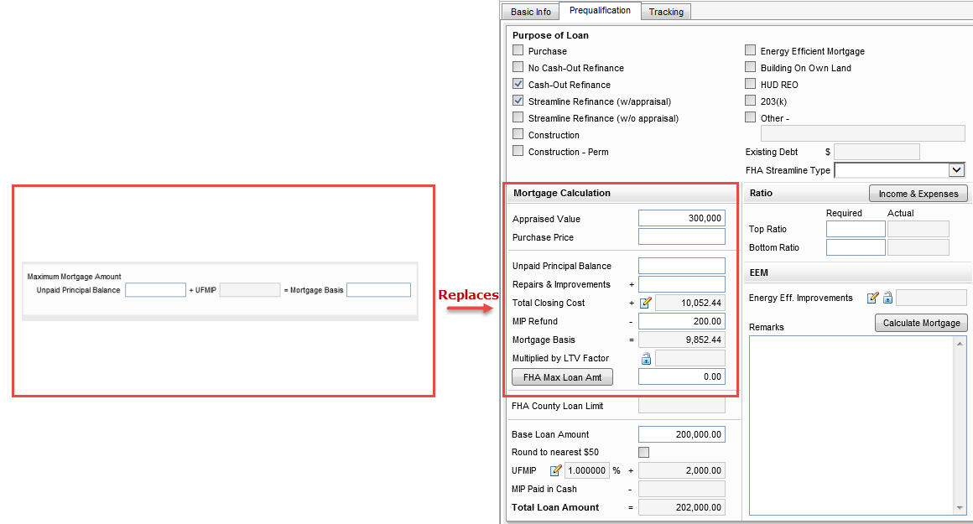

**CASE 5**

**5. Streamline With Appraisal: When field 19 = No cash out refinance and field Mornet.X40 = Streamline w/appraisal, modify the UI on the FHA Management Prequalification screen so that the mortgage calculation represents the below:**

**a. Maximum Mortgage Calculation**

**i. Unpaid Principal Balance [field 26] + New UFMIP = Mortgage Basis [Re-use field GMCAW.X1]**

|  |  |  |  |
| --- | --- | --- | --- |
| **No** | **Test Step** | **Test Data** | **Expected Result** |
| **1** | Log into Encompass as Admin User  Click on Pipeline tab and create a new loan according to data points in 'Test Data' section | * F4000 (First name) = Richard  * F4002 (Last Name) = Borrower  * F52 (Marital Status) = Married  * F65 (SSN) = 991919991  * F1401 (Date of Birth) = 10/30/1980  * F4008 (Type) = Individual  * F1240 (Home Email) = email@email.com  * F1172 (Loan Type) = FHA  * F19 (Purpose of Loan) = No Cash-Out Refi  * Mornet.X40 = Streamline Refinance (w/appraisal)  * F420 (Lien Position) = First  * F763 (Est Closing Date) = Date After Application (F745)  * F1045 (UFMIP) = Any value  * F608 (Amortization Type) = Fixed  * F1811 (Property Will Be) = Primary  * F1109 (Loan Amount) = $200,000  * F3 (Note Rate) = 4%  * F1014 (Qual Rate) = 4%  * F4 (Term) = 360  * F325 (Due In) = 360  * F1821 (Estimated Value) = $250,000  * F356 (Appraised Value) = $250,000  * F26 (Unpaid Principal Balance) = $205,000  * F11 (Address) = 123 Subject Property  * F12 (City) = Anaheim  * F13 (County) = Orange  * F14 (State) = CA  * F15 (Zip) = 92802  * F1041 (Property Type) = Detached  * F682 (First Payment Date) = First of month just after F763 (Est Closing Date)  * F2553 (Disbursement Date) = 3 business days after  * L244 (Interest From) = Same as F2553 (Disbursement Date)  * F748 (Closing Date) = Same as * F763 (Est Closing Date)  * SYS.X2 (Days Per Year) = 365  * F672 (Late Payment > 'If a payment is more than) = Any value  * F674 (Late Payment > 'you will be charged) = Any value  * F1719 (Late Payment "Drop Down") = Any value  * FL0102 (Liabilities > Company name) = Subject Property Mortgage  * FL0108 (Liabilities > Type) = Mortgage  * FL0113 (Liabilities > Balance) = $205,000  * FL0111 (Liabilities > Payment) = $1300  * FL0112 (Liabilities > Mos Left) = 300  * FL0118 (Liabilities > Paid Off) = "checked"  Loan is created |  |
| **2** | Click on 'FHA Management' > 'Prequalification' form |  | User is navigated to the 'FHA Management' > 'Prequalification' form  Validate the following sections are displayed (see attached screenshot):  * Maximum Mortgage Amount'  Validate the "Maximum Mortgage Calculation":  'Unpaid Principal Balance (F26) + 'UFMIP' (F1045) = 'Mortgage Basis'(GMCAW.X1**)** |
|  |  |  |  |

